切片管理工程

参考资料
- 《Phenix.NET企业应用软件快速开发平台.使用指南.12.业务结构对象模型》 “多对多表结构关系及其业务结构-带属性联结表的多对多数据处理方法”章节；

设计要点
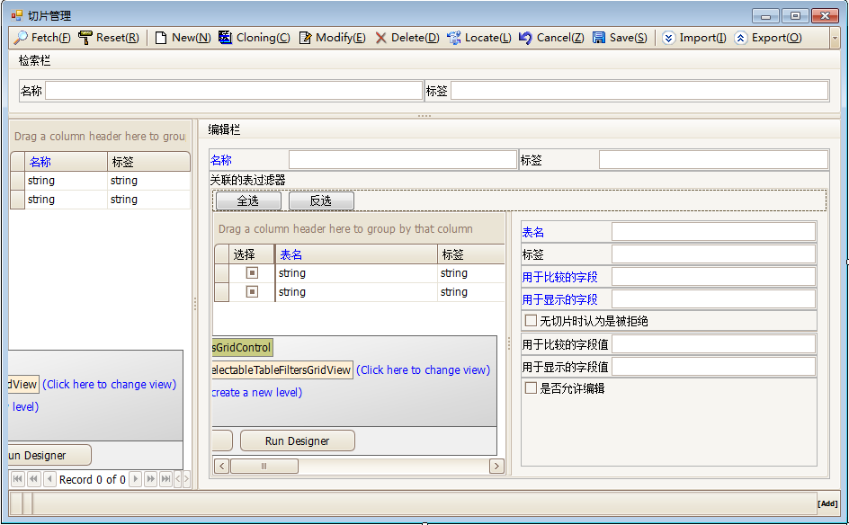
需关注以下几点：
- 表过滤器为切片提供了供选择关联的“表”及其“用于比较的字段”、“用于显示的字段”；
- 切片管理着一组表过滤器，它们之间的关系是or的关系；
- 被切片关联的这些表过滤器，需定义其“用于比较的字段值”、“用于显示的字段值”，才能发挥其作用；
- 当表过滤器未被任何切片关联时，其“无切片时任务是被拒绝”的选项将发挥作用，即当它被勾选时，用户不可能Fetch到数据；
- 当用户拥有该切片时，可Fetch的数据应该与这些表过滤器的 “用于比较的字段值”相匹配，而这些数据是否允许编辑，则受到“是否允许编辑”选项的控制；
- 表过滤器自身的内容，在本界面上是不允许编辑的；

设计分析
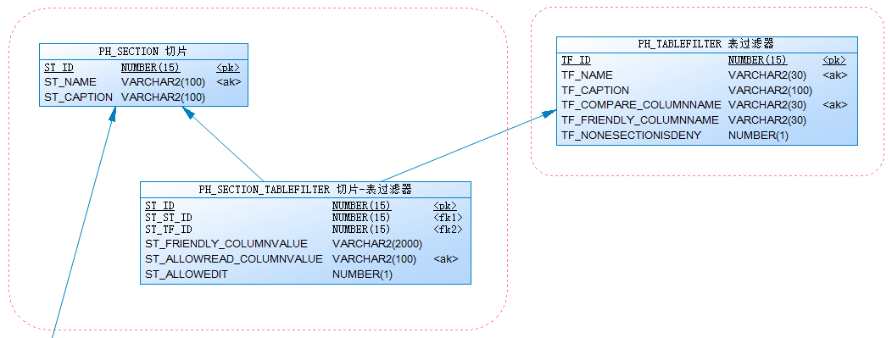
在本业务场景中，切片（PH_SECTION）和表过滤器的关联信息（PH_SECTION_TABLEFILTER）是属于一个业务聚合。

被关联表过滤器的清单
实现了Mapping表PH_SECTION_TABLEFILTER的SectionTableFilter类，其集合类SectionTableFilterList可作为Section对象的SectionTableFilters属性的返回类型，这个属性所返回的值就是Section对象的SectionTableFilterList从业务集合对象：

/// <summary>
/// 分配的表过滤器
/// </summary>
public SectionTableFilterList SectionTableFilters
{
get { return GetDetail<SectionTableFilterList, SectionTableFilter>(); }
}

供勾选的表过滤器清单
我们可以直接操作上文中Section对象的SectionTableFilters属性，对这个集合及其Item对象进行增删改，达成为切片和表过滤器实现关联或取消关联的目的。但为了界面友好，如果能提供一个全集的表过滤器清单，在这个清单里做勾勾选选操作，这样会更加方便，也更直观清晰。

/// <summary>
/// 供勾选的表过滤器全集
/// </summary>
public SelectableTableFilterForSectionList SelectableTableFilters
{
get { return SectionTableFilters.CollatingSelectableList<SelectableTableFilterForSectionList, SelectableTableFilterForSection>(SelectableTableFilterForSectionList.Fetch()); }
}

勾选清单的可编辑模式
按照常规（见《Phenix.NET企业应用软件快速开发平台.权限管理.03.角色管理工程.勾选清单》一文），上述代码，应该是Fetch表过滤器的TableFilterReadOnlyList全景集合对象，但此处使用了新定义的类SelectableTableFilterForSectionList。其原因是我们需要为关联对象SectionTableFilter上的“FriendlyColumnValue、AllowReadColumnValue、AllowEdit_”等属性赋值，见下列黄底代码段：

/// <summary>
/// 切片-表过滤器
/// </summary>
[Phenix.Core.Mapping.ClassAttribute("PH_SECTION_TABLEFILTER", FriendlyName = "切片-表过滤器"), System.SerializableAttribute(), System.ComponentModel.DisplayNameAttribute("切片-表过滤器")]
public abstract class SectionTableFilter<T> : Phenix.Business.BusinessBase<T> where T : SectionTableFilter<T>
{
/// <summary>
/// ST_ID
/// </summary>
public static readonly Phenix.Business.PropertyInfo<long?> ST_IDProperty = RegisterProperty<long?>(c => c.ST_ID);
[Phenix.Core.Mapping.Field(FriendlyName = "ST_ID", TableName = "PH_SECTION_TABLEFILTER", ColumnName = "ST_ID", IsPrimaryKey = true, NeedUpdate = true)]
private long? _ST_ID;
/// <summary>
/// ST_ID
/// </summary>
[System.ComponentModel.DisplayName("ST_ID")]
public long? ST_ID
{
get { return GetProperty(ST_IDProperty, _ST_ID); }
internal set
{
SetProperty(ST_IDProperty, ref _ST_ID, value);
}
}

[System.ComponentModel.Browsable(false)]
[System.ComponentModel.DataAnnotations.Display(AutoGenerateField = false)]
public override string PrimaryKey
{
get { return ST_ID.ToString(); }
}

/// <summary>
/// 所属切片
/// </summary>
public static readonly Phenix.Business.PropertyInfo<long?> ST_ST_IDProperty = RegisterProperty<long?>(c => c.ST_ST_ID);
[Phenix.Core.Mapping.Field(FriendlyName = "所属切片", TableName = "PH_SECTION_TABLEFILTER", ColumnName = "ST_ST_ID", NeedUpdate = true)]
[Phenix.Core.Mapping.FieldLink("PH_SECTION", "ST_ID")]
private long? _ST_ST_ID;
/// <summary>
/// 所属切片
/// </summary>
[System.ComponentModel.DisplayName("所属切片")]
public long? ST_ST_ID
{
get { return GetProperty(ST_ST_IDProperty, _ST_ST_ID); }
set { SetProperty(ST_ST_IDProperty, ref _ST_ST_ID, value); }
}

/// <summary>
/// 所属表过滤器
/// </summary>
public static readonly Phenix.Business.PropertyInfo<long?> ST_TF_IDProperty = RegisterProperty<long?>(c => c.ST_TF_ID);
[Phenix.Core.Mapping.Field(FriendlyName = "所属表过滤器", TableName = "PH_SECTION_TABLEFILTER", ColumnName = "ST_TF_ID", NeedUpdate = true)]
[Phenix.Core.Mapping.FieldLink("PH_TABLEFILTER", "TF_ID")]
private long? _ST_TF_ID;
/// <summary>
/// 所属表过滤器
/// </summary>
[System.ComponentModel.DisplayName("所属表过滤器")]
public long? ST_TF_ID
{
get { return GetProperty(ST_TF_IDProperty, _ST_TF_ID); }
set { SetProperty(ST_TF_IDProperty, ref _ST_TF_ID, value); }
}

/// <summary>
/// 用于显示的字段值
/// </summary>
public static readonly Phenix.Business.PropertyInfo<string> FriendlyColumnvalueProperty = RegisterProperty<string>(c => c.FriendlyColumnValue);
[Phenix.Core.Mapping.Field(FriendlyName = "用于显示的字段值", Alias = "ST_FRIENDLY_COLUMNVALUE", TableName = "PH_SECTION_TABLEFILTER", ColumnName = "ST_FRIENDLY_COLUMNVALUE", NeedUpdate = true)]
private string _friendlyColumnValue;
/// <summary>
/// 用于显示的字段值
/// </summary>
[System.ComponentModel.DisplayName("用于显示的字段值")]
public string FriendlyColumnValue
{
get { return GetProperty(FriendlyColumnvalueProperty, _friendlyColumnValue); }
set { SetProperty(FriendlyColumnvalueProperty, ref _friendlyColumnValue, value); }
}

/// <summary>
/// 用于比较的字段值
/// </summary>
public static readonly Phenix.Business.PropertyInfo<string> AllowreadColumnvalueProperty = RegisterProperty<string>(c => c.AllowReadColumnValue);
[Phenix.Core.Mapping.Field(FriendlyName = "用于比较的字段值", Alias = "ST_ALLOWREAD_COLUMNVALUE", TableName = "PH_SECTION_TABLEFILTER", ColumnName = "ST_ALLOWREAD_COLUMNVALUE", NeedUpdate = true)]
private string _allowReadColumnValue;
/// <summary>
/// 用于比较的字段值
/// </summary>
[System.ComponentModel.DisplayName("用于比较的字段值")]
public string AllowReadColumnValue
{
get { return GetProperty(AllowreadColumnvalueProperty, _allowReadColumnValue); }
set { SetProperty(AllowreadColumnvalueProperty, ref _allowReadColumnValue, value); }
}

/// <summary>
/// 是否允许编辑
/// </summary>
public static readonly Phenix.Business.PropertyInfo<bool?> AllowEditProperty = RegisterProperty<bool?>(c => c.AllowEdit_);
[Phenix.Core.Mapping.Field(FriendlyName = "是否允许编辑", Alias = "ST_ALLOWEDIT", TableName = "PH_SECTION_TABLEFILTER", ColumnName = "ST_ALLOWEDIT", NeedUpdate = true)]
private bool? _allowEdit_;
/// <summary>
/// 是否允许编辑
/// </summary>
[System.ComponentModel.DisplayName("是否允许编辑")]
public bool? AllowEdit_
{
get { return GetProperty(AllowEditProperty, _allowEdit_); }
set { SetProperty(AllowEditProperty, ref _allowEdit_, value); }
}
}

需持久化到表中：
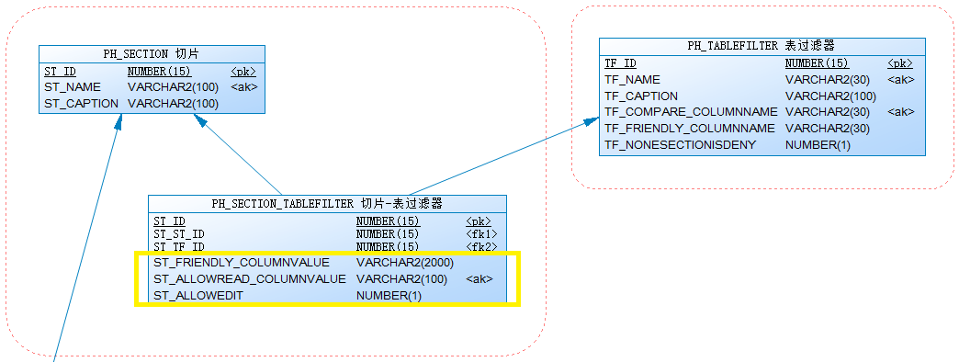
由于我们是通过操作表过滤器对象来间接操作SectionTableFilter对象的，所以，要在表过滤器对象上添加这些额外属性，才能间接为SectionTableFilter对应的属性赋值。为此，需新建一个SelectableTableFilterForSection类，让它继承自TableFilter泛型类，然后我们在它上面定义上与SectionTableFilter相对应的属性（可以将上述黄底代码拷贝粘贴过来），并将它们的Mapping字段标签内容设置成“NoMapping = true”，以便告知Phenixヾ在执行Fetch操作的时候，应该忽略掉它们；而 “NeedUpdate = true”的设置在这里是无意义的，可以被删掉，因为Phenixヾ实质上是会自动对关联的SectionTableFilter对象上对应的字段进行赋值（通过“IsRedundanceColumn = true”），真正提交到数据库的是SectionTableFilter对象：

/// <summary>
/// 供切片勾选的表过滤器
/// </summary>
[Serializable]
public class SelectableTableFilterForSection : TableFilter<SelectableTableFilterForSection>
{
#region 需覆写SectionTableFilter的属性: NoMapping = true, IsRedundanceColumn = true

/// <summary>
/// 用于显示的字段值
/// </summary>
public static readonly Phenix.Business.PropertyInfo<string> FriendlyColumnvalueProperty = RegisterProperty<string>(c => c.FriendlyColumnValue);
[Phenix.Core.Mapping.Field(FriendlyName = "用于显示的字段值", Alias = "ST_FRIENDLY_COLUMNVALUE", TableName = "PH_SECTION_TABLEFILTER", ColumnName = "ST_FRIENDLY_COLUMNVALUE", NoMapping = true, IsRedundanceColumn = true)]
private string _friendlyColumnValue;
/// <summary>
/// 用于显示的字段值
/// </summary>
[System.ComponentModel.DisplayName("用于显示的字段值")]
public string FriendlyColumnValue
{
get { return GetProperty(FriendlyColumnvalueProperty, _friendlyColumnValue); }
set { SetProperty(FriendlyColumnvalueProperty, ref _friendlyColumnValue, value); }
}

/// <summary>
/// 用于比较的字段值
/// </summary>
public static readonly Phenix.Business.PropertyInfo<string> AllowreadColumnvalueProperty = RegisterProperty<string>(c => c.AllowReadColumnValue);
[Phenix.Core.Mapping.Field(FriendlyName = "用于比较的字段值", Alias = "ST_ALLOWREAD_COLUMNVALUE", TableName = "PH_SECTION_TABLEFILTER", ColumnName = "ST_ALLOWREAD_COLUMNVALUE", NoMapping = true, IsRedundanceColumn = true)]
private string _allowReadColumnValue;
/// <summary>
/// 用于比较的字段值
/// </summary>
[System.ComponentModel.DisplayName("用于比较的字段值")]
public string AllowReadColumnValue
{
get { return GetProperty(AllowreadColumnvalueProperty, _allowReadColumnValue); }
set { SetProperty(AllowreadColumnvalueProperty, ref _allowReadColumnValue, value); }
}

/// <summary>
/// 是否允许编辑
/// </summary>
public static readonly Phenix.Business.PropertyInfo<bool?> AllowEditProperty = RegisterProperty<bool?>(c => c.AllowEdit_);
[Phenix.Core.Mapping.Field(FriendlyName = "是否允许编辑", Alias = "ST_ALLOWEDIT", TableName = "PH_SECTION_TABLEFILTER", ColumnName = "ST_ALLOWEDIT", NoMapping = true, IsRedundanceColumn = true)]
private bool? _allowEdit_;
/// <summary>
/// 是否允许编辑
/// </summary>
[System.ComponentModel.DisplayName("是否允许编辑")]
public bool? AllowEdit_
{
get { return GetProperty(AllowEditProperty, _allowEdit_); }
set { SetProperty(AllowEditProperty, ref _allowEdit_, value); }
}

#endregion
}

类结构关系如下所示：
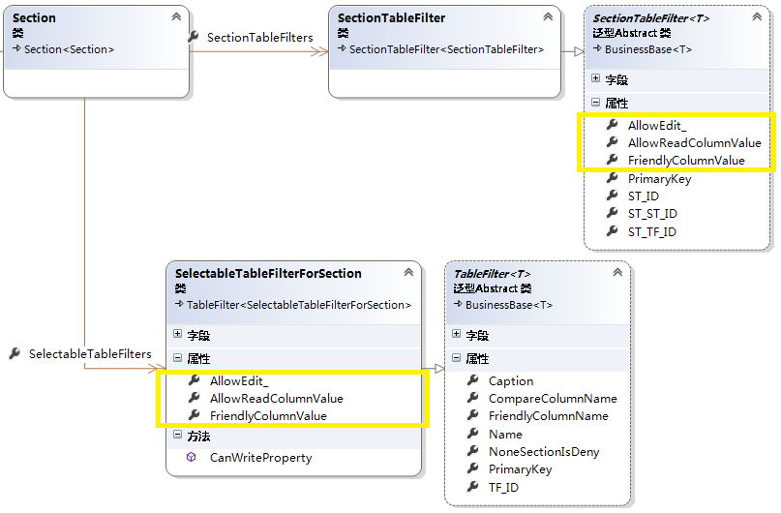
至此，已完成了我们的业务逻辑层编写工作，剩余的业务逻辑就交给Phenixヾ来自动处理了。接下来，界面的设计可按照以往的开发步骤操作。
运行效果如下：
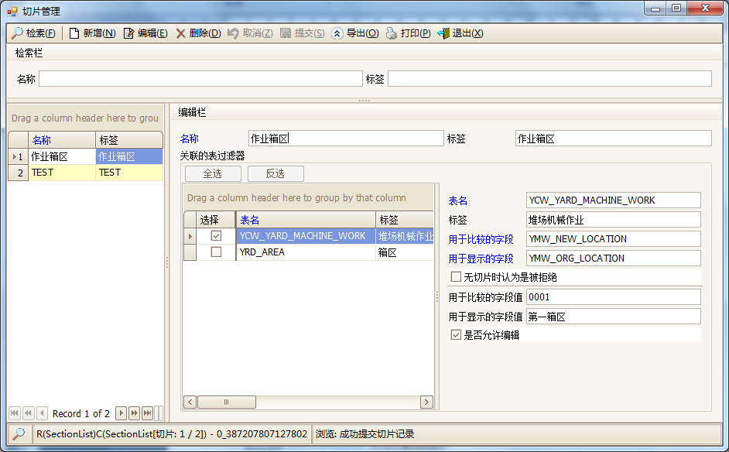

禁止编辑的属性
由于供勾选的SelectableTableFilterForSection对象是直接继承自TableFilter泛型类的，缺省下其所有属性是允许编辑的。但是我们仅允许“FriendlyColumnValue、AllowReadColumnValue、AllowEdit_”这三个属性可以编辑，所以需重载业务类的CanWriteProperty()函数：

/// <summary>
/// 属性可写
/// </summary>
/// <param name="property">属性信息</param>
/// <returns>属性可写</returns>
public override bool CanWriteProperty(Csla.Core.IPropertyInfo property)
{
//非“需覆写SectionTableFilter的属性”一概不允许写
if (property != null)
if (!property.Equals(FriendlyColumnValueProperty) &&
!property.Equals(AllowReadColumnValueProperty) &&
!property.Equals(AllowEditProperty))
return false;
return base.CanWriteProperty(property);
}

注意，最后一行代码是调用基类的CanWriteProperty()函数。而之前的代码中，要是中途退出函数的话，都应该是return false，以保证“一票否决”，所有可能的否决票都被征询过。

完整代码

SelectableTableFilterForSection

/// <summary>
/// 供切片勾选的表过滤器
/// </summary>
[Serializable]
public class SelectableTableFilterForSection : TableFilter<SelectableTableFilterForSection>
{
#region 需覆写SectionTableFilter的属性: NoMapping = true, IsRedundanceColumn = true

/// <summary>
/// 用于显示的字段值
/// </summary>
public static readonly Phenix.Business.PropertyInfo<string> FriendlyColumnvalueProperty = RegisterProperty<string>(c => c.FriendlyColumnValue);
[Phenix.Core.Mapping.Field(FriendlyName = "用于显示的字段值", Alias = "ST_FRIENDLY_COLUMNVALUE", TableName = "PH_SECTION_TABLEFILTER", ColumnName = "ST_FRIENDLY_COLUMNVALUE", NoMapping = true, IsRedundanceColumn = true)]
private string _friendlyColumnValue;
/// <summary>
/// 用于显示的字段值
/// </summary>
[System.ComponentModel.DisplayName("用于显示的字段值")]
public string FriendlyColumnValue
{
get { return GetProperty(FriendlyColumnvalueProperty, _friendlyColumnValue); }
set { SetProperty(FriendlyColumnvalueProperty, ref _friendlyColumnValue, value); }
}

/// <summary>
/// 用于比较的字段值
/// </summary>
public static readonly Phenix.Business.PropertyInfo<string> AllowreadColumnvalueProperty = RegisterProperty<string>(c => c.AllowReadColumnValue);
[Phenix.Core.Mapping.Field(FriendlyName = "用于比较的字段值", Alias = "ST_ALLOWREAD_COLUMNVALUE", TableName = "PH_SECTION_TABLEFILTER", ColumnName = "ST_ALLOWREAD_COLUMNVALUE", NoMapping = true, IsRedundanceColumn = true)]
private string _allowReadColumnValue;
/// <summary>
/// 用于比较的字段值
/// </summary>
[System.ComponentModel.DisplayName("用于比较的字段值")]
public string AllowReadColumnValue
{
get { return GetProperty(AllowreadColumnvalueProperty, _allowReadColumnValue); }
set { SetProperty(AllowreadColumnvalueProperty, ref _allowReadColumnValue, value); }
}

/// <summary>
/// 是否允许编辑
/// </summary>
public static readonly Phenix.Business.PropertyInfo<bool?> AllowEditProperty = RegisterProperty<bool?>(c => c.AllowEdit_);
[Phenix.Core.Mapping.Field(FriendlyName = "是否允许编辑", Alias = "ST_ALLOWEDIT", TableName = "PH_SECTION_TABLEFILTER", ColumnName = "ST_ALLOWEDIT", NoMapping = true, IsRedundanceColumn = true)]
private bool? _allowEdit_;
/// <summary>
/// 是否允许编辑
/// </summary>
[System.ComponentModel.DisplayName("是否允许编辑")]
public bool? AllowEdit_
{
get { return GetProperty(AllowEditProperty, _allowEdit_); }
set { SetProperty(AllowEditProperty, ref _allowEdit_, value); }
}

#endregion

#region 过程

/// <summary>
/// 属性可写
/// </summary>
/// <param name="property">属性信息</param>
/// <returns>属性可写</returns>
public override bool CanWriteProperty(Csla.Core.IPropertyInfo property)
{
//非“需覆写SectionTableFilter的属性”一概不允许写
if (property != null)
if (!property.Equals(FriendlyColumnValueProperty) &&
!property.Equals(AllowReadColumnValueProperty) &&
!property.Equals(AllowEditProperty))
return false;
return base.CanWriteProperty(property);
}

#endregion
}

Section

/// <summary>
/// 切片
/// </summary>
[Serializable]
[Phenix.Core.Mapping.ClassDetail("PH_SECTION_TABLEFILTER", "ST_ST_ID", null, CascadingDelete = true, FriendlyName = "切片-表过滤器")]
public class Section : Section<Section>
{
#region 勾选表过滤器全集

/// <summary>
/// 分配的表过滤器
/// </summary>
public SectionTableFilterList SectionTableFilters
{
get { return GetDetail<SectionTableFilterList, SectionTableFilter>(); }
}

/// <summary>
/// 供勾选的表过滤器全集
/// </summary>
public SelectableTableFilterForSectionList SelectableTableFilters
{
get { return SectionTableFilters.CollatingSelectableList<SelectableTableFilterForSectionList, SelectableTableFilterForSection>(SelectableTableFilterForSectionList.Fetch()); }
}

#endregion
}

